Thinking cap project proposal

# Problem statement:

Getting into a focused state of maximal creativity/productivity can prove difficult in the modern world. Offices are open and free. Phones ring and vibrate the day away. Computer screens and smartphones constantly have visual, haptic, and audible notifications popping in and out of awareness.

What effect do these constant intrusions on our mental state have with regards to focus? To memory? To well-being? Without even thinking, we can come up with an example. We try to remember something important, but a car honks, and we lose the thought before we can record it. We are tackling a puzzle at work, starting to get a grasp on it, and our phone lights up and buzzes with something that doesn’t matter, taking our attention away from the problem and forcing us to find our way back to the thread we need to pull at.

Each notification and distraction means to be helpful, but in frequent aggregate, makes us helpless.

The world is designed to distract us. To be the best, we need to focus.

# Project description:

In order to reduce disruptions during periods of great focus, it would be useful to have a clear visual indicator that the individual in question is not to be disturbed. A mobile DND for the office, essentially. This would combine visual indicators for in-person interactions with visual indicators and muting functionalities across devices (DND on iPhone, DND on Slack, away in World of Warcraft, etc).

The ideal form factor for something that requires brain access is, of course, a hat. Hats are widely used to express ideas already. Usually sports team affiliations, to be sure. But a top hat would work even better.

By using an old top hat, there will be enough space to mount the required sensors and indicators, while also providing a modicum of disguise to the EEG reader. Plus, it will look super nerdy and British. The brim of the hat can be used to attach controllers such as buttons. The EEG reader is just inside the brim. The top of the hat, but still inside, could contain the Arduino. LEDs on the back, facing anybody sneaking up to attack the wearer’s attention.

Care has to be taken to keep it light and not a fire hazard, and make sure the EEG reader is insulated from any electrical interference.

P9000 EEG. Can tell when focus moves to something else.

# Requirements:

Wearable EEG device – Ok

Focus state can be determined through wave analysis – To be determined through experimentation

API access to Slack to control status and turn notifications off – OK to use Do Not Disturb

Arduino to control physical controls and LEDs – Ok

Computer or Raspberry Pi to interface with the various devices and APIs – OK. Can just connect my machine to the Arduino for now.

Inputs - sensors:

5 buttons counts as one input though.  
Accelerometer to detect if the hat was on the table or on a head. Or to see if user turns head within a table’s worth of space. If beyond 180* can turn DND off?  
Button on brim to manually override DND status  
EEG reader  
Serial (to sync Arduino & lights with master DND status)  
Separate controls for devices and physical indicators. Sometimes want them unlinked.  
Maybe a sound detector.

Outputs/displays:

Serial  
LEDs  
Maybe something to shock interlopers  
LED strip w/ text cycling through. Green vs red.  
Flag on a motor. Up to 90* and down to 0. Like a mailbox. Straws w/ flags?

Stop sign. Twist and erect. 2 flags.  
Motors attached to blinders?

# References:

Slack API (search for dnd): <https://api.slack.com/methods>

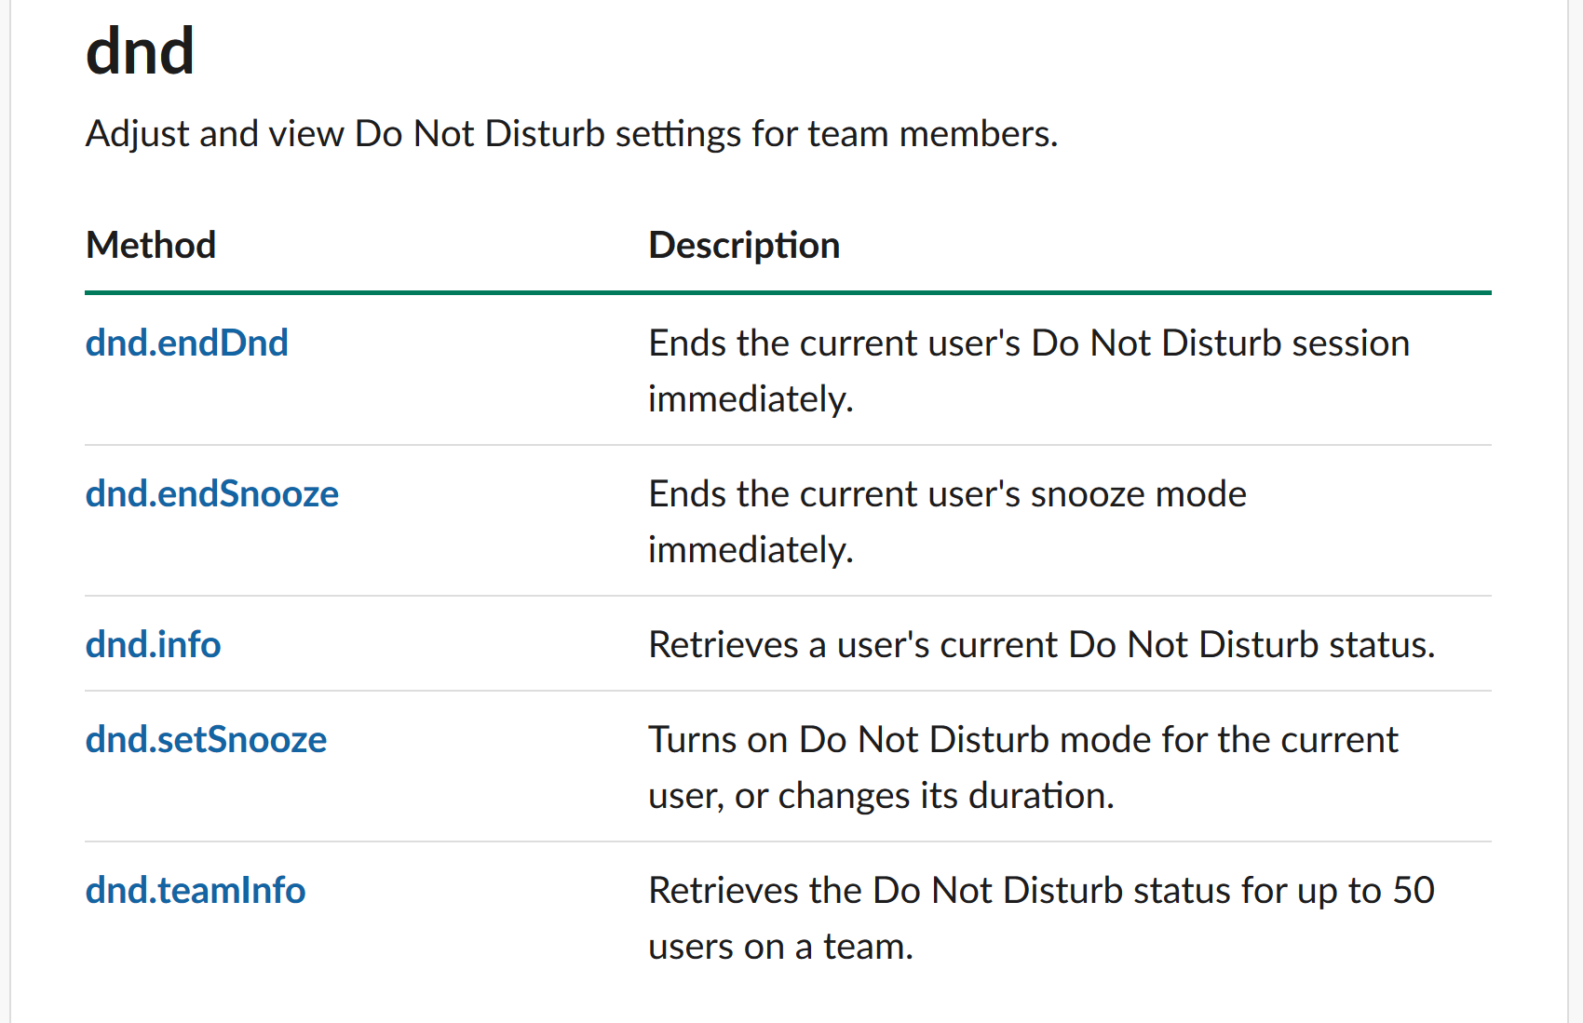

Mute Android: <https://ifttt.com/applets/XN9H6acu-automatically-mute-your-android-phone-at-bedtime>

Notes from other students’ presentations:

Resistive foam.

Touch sensors.

Screens don’t count as inputs, nor do cameras.

Analogs for screen inputs.

Sandbox w/ depth sensors.

Start and mode.

Stepper motor

Terrarium store – the terrarium shop